IDEATION PHASE

EMPATHIZE & DISCOVER
Date: 30 September 2026
Team ID: 6ab24e39f627ed373bc88e68
Project Name: Streamlining IT Procurement: Automating Standard Laptop Orders with Flow Designer
Maximum Marks: 4 Marks

Empathy Map Canvas
An empathy map is a simple, easy-to-digest visual that captures knowledge about a user’s behaviours and attitudes.
It is a useful tool to help teams better understand their users.
Creating an effective solution requires understanding the true problem and the person who is experiencing it. The exercise of creating the map helps participants consider things from the user’s perspective along with his or her goals and challenges.
Reference: https://www.mural.co/templates/empathy-map-canvas

Empathy Map Diagram
PASTE THE GENERATED EMPATHY MAP DIAGRAM HERE.
The diagram represents the thoughts, statements, activities, feelings, difficulties, and expected benefits of the IT procurement team member while handling Standard Laptop requests.

User Persona

Primary User: IT Procurement Team Member
The primary user of the proposed system is a member of the IT procurement team who handles Standard Laptop requests.
The user is responsible for ensuring that laptop requests are processed properly and that the required configuration activities are completed by the Hardware team.
The user needs a procurement process that is simple, efficient, consistent, and less dependent on manual activities.

Empathy Map Analysis

1. SAYS
The IT procurement team member may say:
- “The laptop request has been approved.”
- “The configuration task needs to be created.”
- “The Hardware team needs to receive the task.”
- “Manual task creation takes additional time.”
- “The process should be faster and easier.”
- “I want to avoid missing any configuration task.”
These statements show that the user wants the laptop procurement process to be completed smoothly and without unnecessary manual work.

2. THINKS
The IT procurement team member may think:
- “Has the configuration task been created?”
- “Has the task been assigned to the Hardware team?”
- “Could the task be delayed or overlooked?”
- “Can this repetitive activity be automated?”
- “The process should be more systematic.”
- “Automation could reduce my workload.”
These thoughts indicate that the user is concerned about task creation, task assignment, delays, and repetitive manual activities.

3. DOES
The IT procurement team member:
- Receives or handles Standard Laptop requests.
- Checks the request status.
- Monitors the approval process.
- Checks the Requested Item.
- Handles configuration-related tasks.
- Coordinates with the Hardware team.
- Tracks the progress of the laptop request.
- Ensures that the laptop is configured before delivery.
These activities show that the user is involved in several stages of the laptop procurement and configuration process.

4. FEELS
The IT procurement team member may feel:
- Frustrated when manual activities take additional time.
- Concerned when a task is delayed.
- Worried about missing a configuration task.
- Responsible for ensuring that requests are processed correctly.
- Relieved when tasks are automatically created and assigned.
- Satisfied when the procurement process works smoothly.
These feelings show the importance of creating a reliable and efficient process for handling laptop requests.

5. PAINS
The main difficulties experienced by the user are:
- Manual creation of configuration tasks.
- Additional administrative workload.
- Possible delays after request approval.
- Possibility of overlooking a task.
- Manual assignment of tasks.
- Difficulty maintaining consistency in repetitive activities.
- Increased processing time.
- Additional coordination with the Hardware team.
These pain points can affect the efficiency of the IT procurement process and may increase the waiting time for users.

6. GAINS
The user expects the following improvements:
- Automatic creation of configuration tasks.
- Automatic assignment to the Hardware team.
- Reduced manual intervention.
- Faster processing of laptop requests.
- Consistent task information.
- Better tracking of configuration activities.
- Improved resource utilization.
- Reduced user waiting time.
- Improved overall procurement efficiency.
- Better user experience.
These gains represent the improvements that the proposed automation should provide to the IT procurement process.
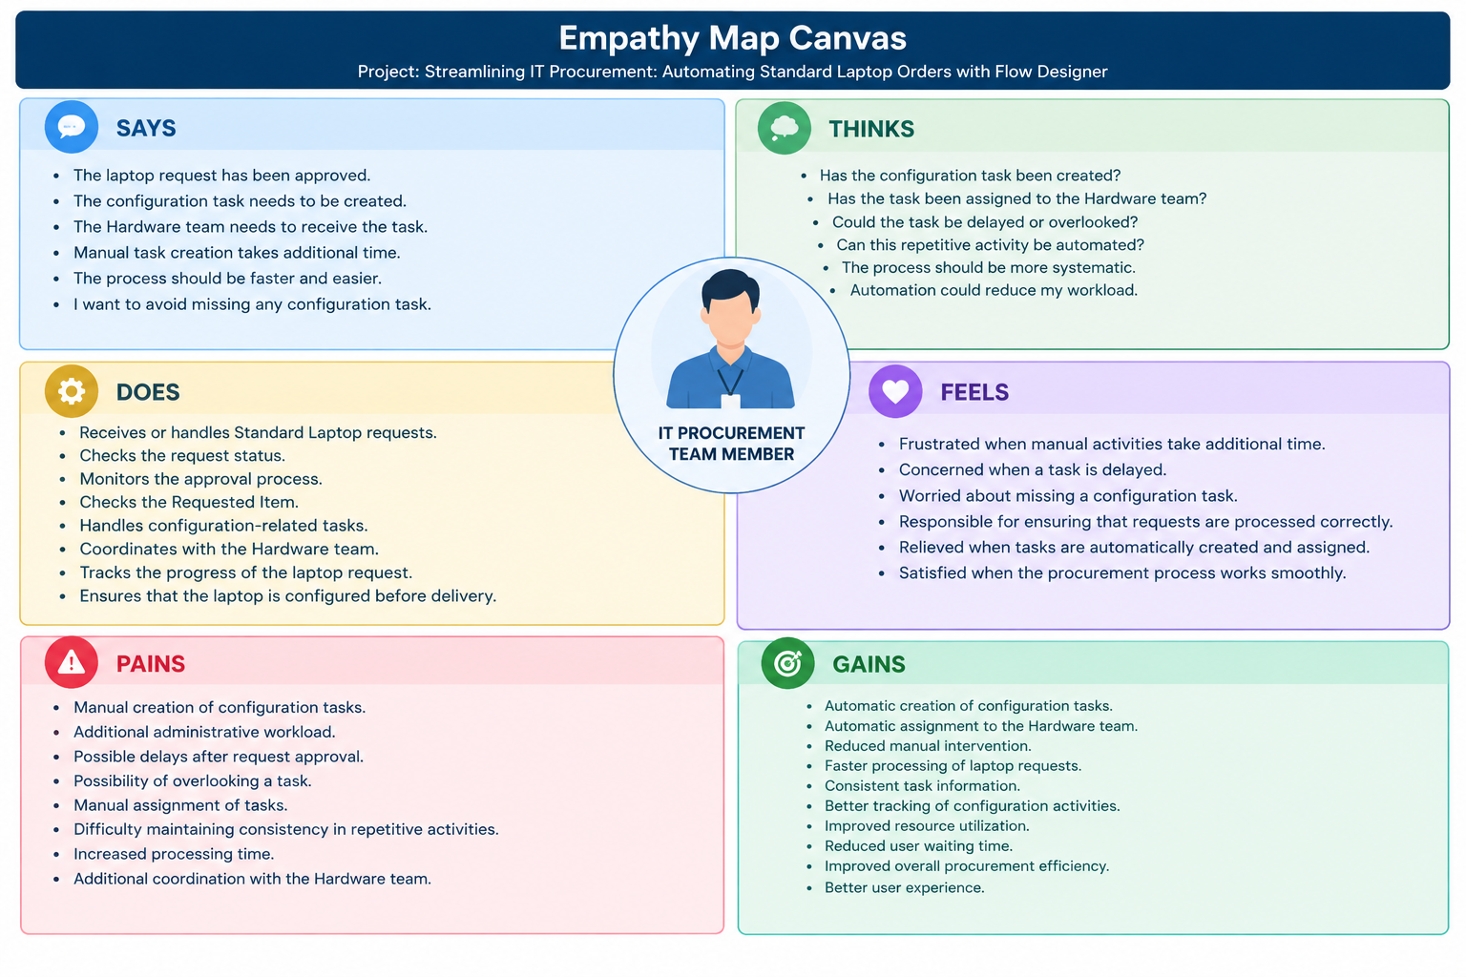

User Needs Identified
Based on the empathy map, the following user needs were identified:
- The user needs a simple and efficient procurement process.
- The user needs automatic task creation after the required approval stage.
- The user needs the task to be assigned to the correct Hardware team.
- The user needs better visibility of the configuration process.
- The user needs reduced manual intervention.
- The user needs a consistent workflow.
- The user needs faster processing of Standard Laptop requests.
- The user needs a process that reduces the possibility of missing or delaying configuration tasks.

Key Insights from Empathize & Discover
The empathy exercise helped the team understand the IT procurement team member’s perspective, behaviour, goals, and challenges.
The major challenge is not only submitting the Standard Laptop request. The configuration activity after approval is also an important part of the procurement process.
Once the request is approved, a configuration task needs to be created and assigned to the Hardware team. Manual handling of this activity can create additional work and may result in delays or oversight.
The empathy map therefore shows that the user needs an automated and consistent process that connects the approved Standard Laptop request with the Hardware configuration task.
The findings support the use of ServiceNow Flow Designer as the proposed automation solution.

Proposed Solution Based on User Needs
Based on the information collected through the Empathize & Discover activity, the proposed solution is to automate the Standard Laptop configuration task using ServiceNow Flow Designer.
The proposed process is:
Standard Laptop Request
↓
Request Approval
↓
Flow Designer
↓
Create Catalog Task
↓
Assign to Hardware
↓
Laptop Configuration
This process can reduce repetitive manual activities and help the Hardware team receive the required configuration task in a structured manner.

Expected User Experience
With the proposed automated process, the user can expect:
- Less manual task creation.
- Faster movement of approved requests to the configuration stage.
- Consistent task information.
- Automatic Hardware team assignment.
- Easier tracking of the configuration task.
- Reduced administrative workload.
- Improved procurement efficiency.
- Reduced waiting time for the laptop user.
The solution is designed to address the needs and pain points identified during the empathy exercise.

Conclusion
The Empathize & Discover Phase helped the team understand the IT procurement team member’s perspective, behaviour, goals, challenges, and expectations.
The Empathy Map Canvas identified important information under Says, Thinks, Does, Feels, Pains, and Gains.
The major pain points identified were manual task creation, additional administrative workload, possible delays, task oversight, manual assignment, and increased processing time.
The major gains identified were automatic task creation, automatic Hardware assignment, reduced manual intervention, faster processing, consistent task information, improved tracking, and better user experience.
Based on these findings, the project proposes the use of ServiceNow Flow Designer to automate the creation and assignment of the Standard Laptop configuration task.
This user-focused understanding provides a strong foundation for the next stages of the project, including Requirement Analysis, Project Design, Project Planning, Project Development, Testing, Documentation, and Demonstration.

